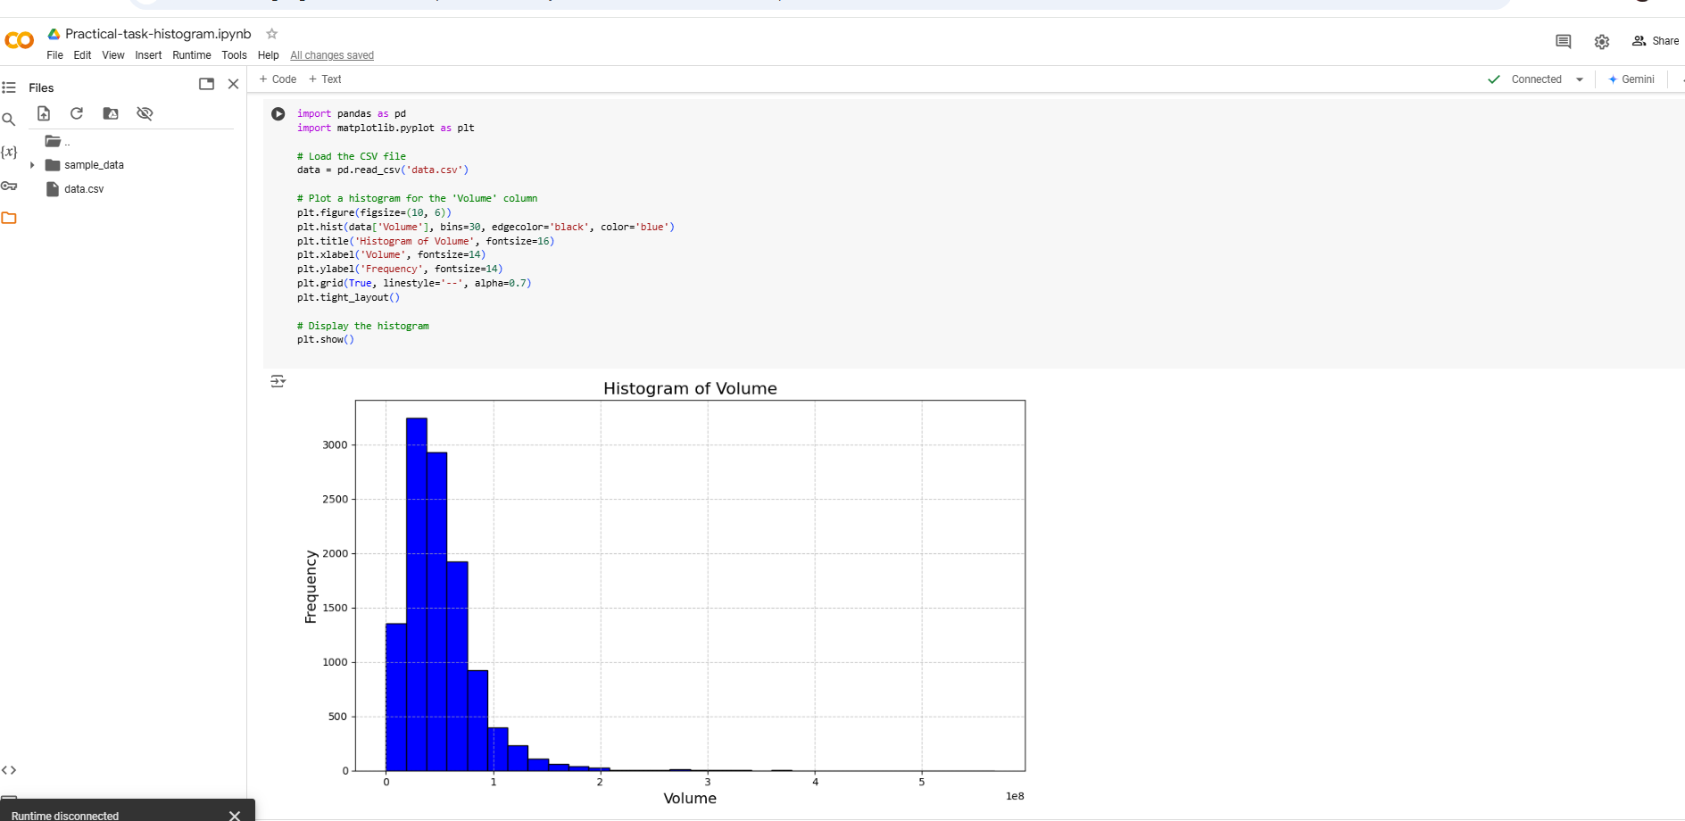

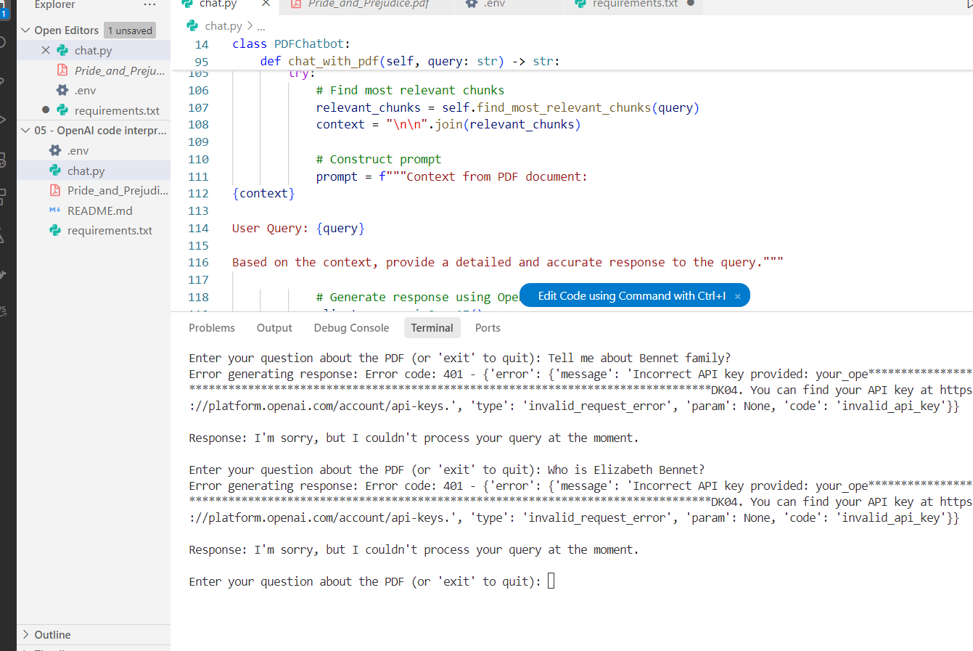

Everything works well however, my OpenAIApi key is old and it demand billing. Only this side gives me error